Webpage Development Process
Mahmudul Alam
Colorado State University – Global Campus
Course Code: 20FA-CSC501-1
Dr. Charles Beverley
Tuesday, August 4, 2020
Webpage Development Process
A webpage can be used to portray product and the business in this E-commerce based society. HTML, CSS and JavaScript can be used to build a website. There are few steps that must be taken for us to build a webpage. Planning a project is the first step, designing plays an important role, coding, testing the page and its features, once we a have a running site we must maintain it. Project manager has critical roles from planning the project to the deployment of the product, Project manager is in charge of timeline of the project, monitoring the progress of the scrum process and mange any unexpected situation while getting done with the project on time. Project scope is a well-defined section in the project development life cycle. Project scope is part of planning based on the requirements, the main objective of the project scope is to come up with specific goals and deliverables.
3D printer’s Site Plan
We have three types of 3D printer in our company. First type is within reasonable price which can be used by regular people, second item can be used by the educational institutions and small business for academic and research reasons. Third type of printer can be used commercially for production purposes for 3D products. There are existing compotators in the market. Most of those sites are traditional sites with different pages connected to it. They have the main page and drop down to other pages for different products. We have to be creative and different with our marketing at the same time we have to make sure we are portraying the actual product we have using all the possible technologies and features possible.
We can use 3D images on our page while making a dynamic site using Augmented reality technology. When the visitors will visit the site, they will be displayed with moving images and very little amount of texts. This format of the page will give us the opportunity to showcase our products from every possible angle. Planning for the site is important, according to the website development process/Full Guide as a project manager for this new 3d printer site I will do intensive research about the product we are selling, future customer preference, current market for the business and other similar companies how they are operating their business through the websites.
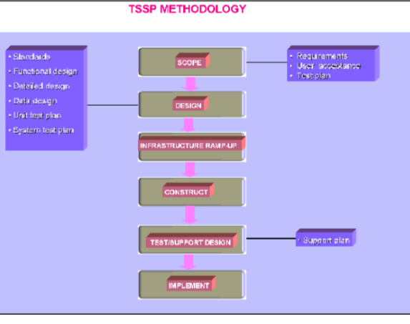
This diagram is from Maria Jakovljevic
There are certain procedures must be followed which will make sure the end result of a development process comes out successful. According to the diagram there are certain standard such as functional design detailed design, data design, unit test plan, system test plan. After maintaining those standards, we must divide the project into scope, designing come after, making sure all the right machines and software are available, once everything is set construction begins, testing becomes important. I will also implement this type of system building my page for our printers. According to Maria Jakovljevic “In creation and invention, there are always states of order and disorder (Hill, 1998:216). However, practice reveals that it is also a systematic, step-by-step guided process.” A well-set system is the key to a successful project, having a well-planned scope and steps aligning with the requirements is my true goal for the project.
Scope management process
We are going to use JIRA to keep trac of the sprints and project progress, GitHub, or bit bucked to store the code, visual studio or eclipse to write code, we have the AWS web services for database and other web service if needed. We will test our software with selenium and cucumber and postman for API
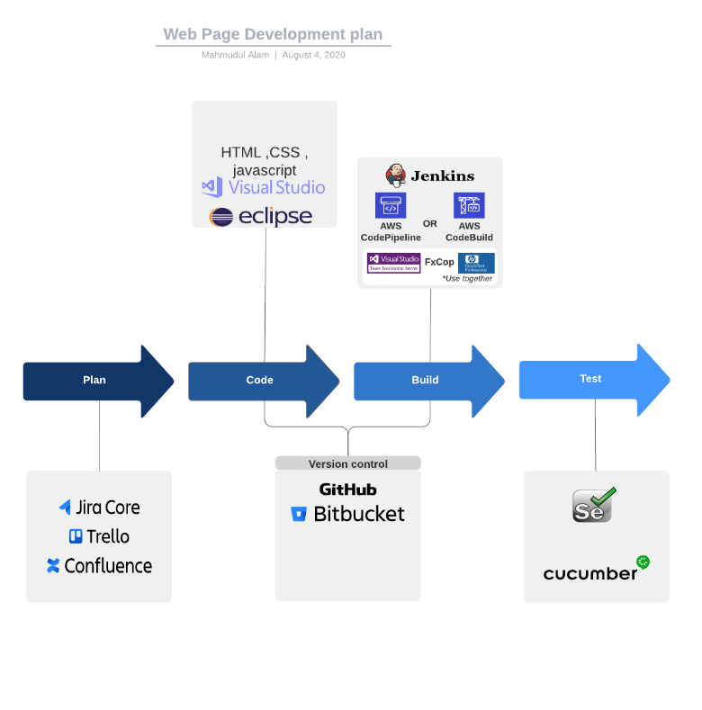
This diagram was built using Lucidchat Temples
Development Process
We are going to have seven components to our development process.
- Requirement Specifications
- Component Analysis
- Requirement Modification
- System design
- Development and integrate
- System validation
As a project manager with the systems engineer, I will write the sprints implementing different tolls at different stage of the development process. According to Osman Abd allah Nasr Ali, “Project management is one of the key tools used to achieve a strategic plan by ensuring that a project is completed and delivered in due time, and with respect to quality and cost requirements [1]. Many aspects define a project management: activities, time, cost, quality, human resources, communication, risk and procurement.” I will have the most important role throughout the project. I must make sure the integration goes right, and we are on track deploying the product on time.
Conclusion
Short, simple, and dynamic web page with the 3 images are the bases for our new 3D printer’s page. We have 6 phases from the requirements to the final product. We are going to use different technologies and tool at different phases to have the best working flow for the project. Use of many tools and the process for the project will allow us to deal with scope creep situations and we will be able deliver the product on time.

References
Osman Abd allah Nasr Ali. (2020). Developing a Software Mechanism for Scheduling and Tracking Project Lifecycle Using Open-Source Software: An application on a government institution. Journal of Information Systems and Informatics, 2(1), 12–22. https://doi.org/10.33557/journalisi.v2i1.28
Maria Jakovljevic, Piet Ankiewicz, & Estelle de Swardt. (2000). Technological stages in the system development life cycle: an application to Web page design. South African Journal of Information Management, 2(2/3). https://doi.org/10.4102/sajim.v2i2/3.98

